Name: ______________________________ Date: ____________
Directions: Please read the passage. Then determine the main idea and three details from the passage.
A Very Large Reptile
Boa constrictors are amazing snakes. Like all snakes, boa constrictors are reptiles and cold-blooded. Boa constrictors are non-venomous (not poisonous) and must rely on other methods to kill and eat their prey. These snakes kill by constriction, wrapping their body around and squeezing the prey until it dies. (Remember, no warm hugs for these snakes!)
Not as big as anacondas, most boa constrictors can be as small as 30 inches (a little smaller than a yardstick) or as big as 10 feet. The biggest one every found over 18 feet long. That is about as long as a truck. They can weigh over 100 pounds.
Boa constrictors can be found in Central and South America. They will eat almost anything they can catch. They eat birds, other reptiles, monkeys, and even pigs. Their meal of choice is rodent. They are nocturnal hunters, searching for a meal in the dark of night. Often, they hang from trees by a cave and wait for a bat to fly by. They don’t chew their food up like you and I. After they catch the prey, they swallow it whole! If it is a big meal, their jaws can stretch wide to get it all in. They usually live about 20 to 30 years.
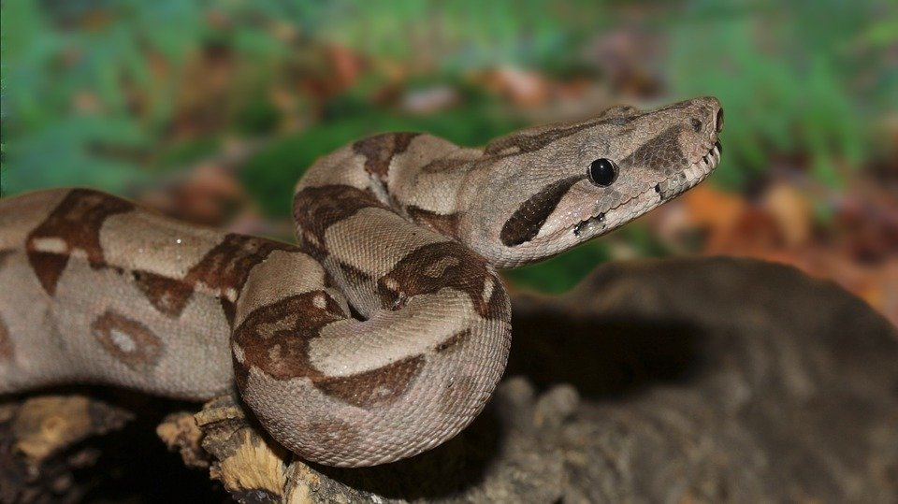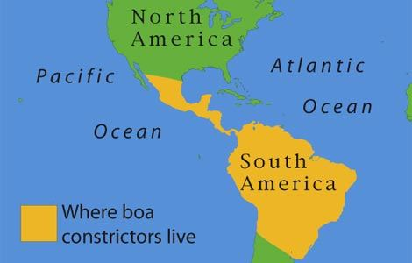
Main Idea:

Key Detail #1:

Key Detail #2:

Key Detail #3:

